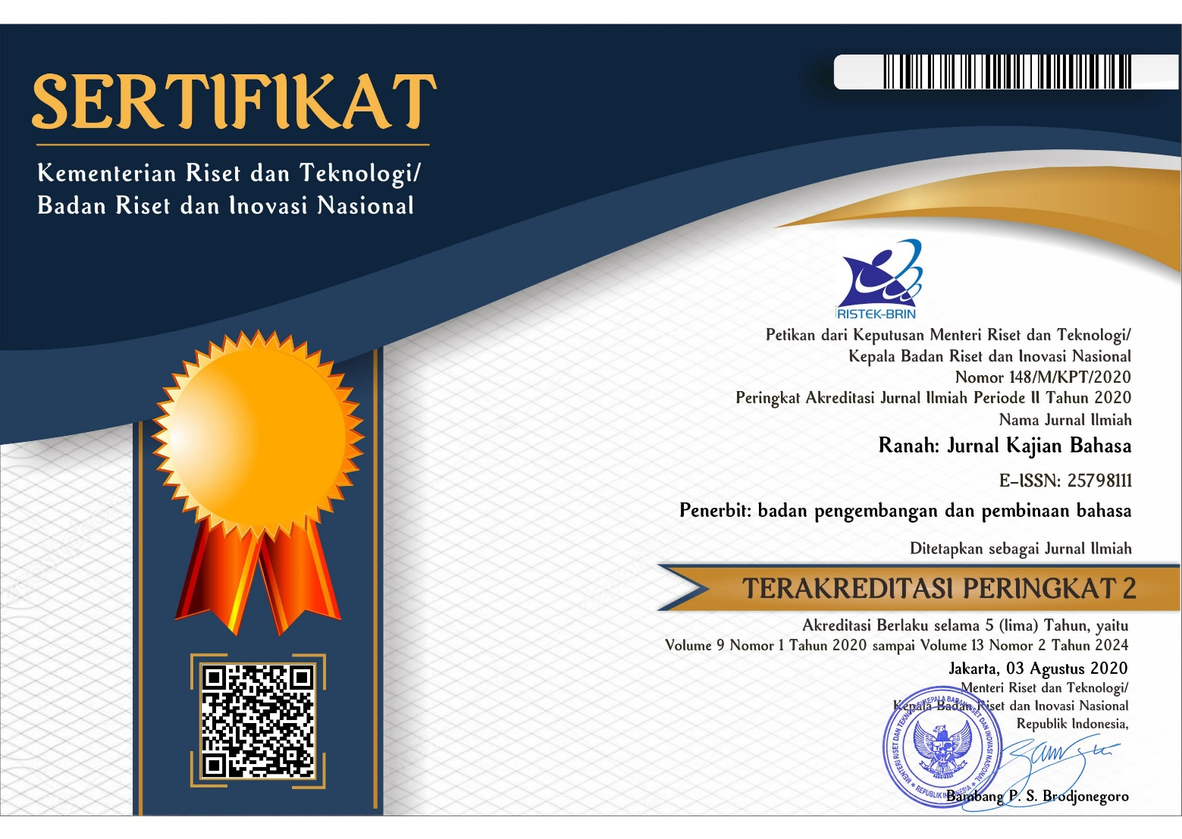

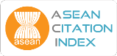

Ranah: Journal of Language Studies is published by the National Agency for Language Development and Cultivation. It is a research journal which publishes various research reports, literature studies and scientific writings on phonetics, phonology, morphology, syntax, discourse analysis, pragmatics, anthropolinguistics, language and culture, dialectology, language documentation, forensic linguistics, comparative historical linguistics, cognitive linguistics, computational linguistics, corpus linguistics, neurolinguistics, language education, translation, language planning, psycholinguistics, sociolinguistics and other scientific fields related to language studies. It is published periodically twice a year in June and December. Each article published in Ranah will undergo assessment process by peer reviewers.
Ranah: Journal of Language Studies has been accredited PERINGKAT 2 or SINTA 2 at 3rd August 2020 by Indonesia Ministry of Research, Technology and Higher Education of The Republic of Indonesia as an achievement for the peer-reviewed journal which has excellent quality in management and publication. The recognition published in Director Decree (SK No 148/M/KPT/2020) and effective until December 2024.

Editorial Office:
Badan Pengembangan dan Pembinaan Bahasa
Kementerian Pendidikan, Kebudayaan, Riset dan Teknologi
Jalan Daksinapati Barat IV, Rawamangun, Jakarta Timur
Pos-el: jurnalranahbahasa@gmail.com
Laman: bit.ly/jurnalranah
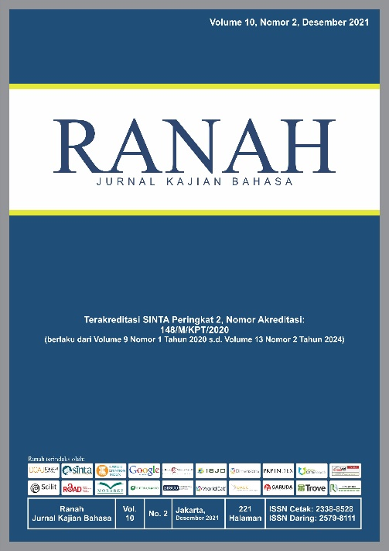

Editorial and Reviewer Team
Editor In Chief
Winci Firdaus, Scopus ID: 57205062723, Badan Pengembangan dan Pembinaan Bahasa, Indonesia

Managing Editor
Wati Kurniawati, Badan Pengembangan dan Pembinaan Bahasa

Editorial Boards
Luh Anik Mayani, Garuda ID: 1011212, SEAMEO QITEP in Language, Indonesia
Indrya Mulyaningsih, Scopus ID: 57200991886, IAIN Syekh Nurjati Cirebon, Indonesia
Fahmi Gunawan, Scopus ID: 57199720154, Institut Agama Islam Negeri Kendari, Indonesia
Buha Aritonang, Garuda ID: 629864, Badan Pengembangan dan Pembinaan Bahasa, Indonesia
Wahyudi Rahmat, Scopus ID: 57204044908, STKIP PGRI Sumatera Barat, Indonesia
Santi Yulianti, Badan Pengembangan dan Pembinaan Bahasa, Indonesia
Djamari, Badan Pengembangan dan Pembinaan Bahasa, Indonesia

Peer-Reviewers

Prof. E. Aminuddin Aziz, M.A., Ph.D. Badan Pengembangan dan Pembinaan Bahasa, Indonesia
Prof. Dr. Dadang Sunendar, M.Hum. Scopus ID: 57200340802, Universitas Pendidikan Indonesia, Indonesia
Prof. Dr. Gufran Ali Ibrahim. Scopus ID: 53552058304, Universitas Khairun, Indonesia
Prof. Dr. Multamia RMT. Lauder. Scopus ID: 57201059503, Universitas Indonesia, Indonesia
Prof. Dr. Nikolaus P. Himmelmann. Orcid ID: 0000-0002-4385-8395, University of Cologne, Germany
Prof. Dr. Endry Boeriswati. Scopus ID: 57209220794, Universitas Negeri Jakarta, Indonesia
Prof. Dr. Cece Sobarna, M.Hum. SINTA ID: 6068110, Universitas Padjadjaran, Bandung, Indonesia
Prof. Dr. Endang Fauziati. Scopus ID: 57188558465, Universitas Muhammadiyah Surakarta, Indonesia
Prof. Dr. Pranowo. Scopus ID: 57211394211, Unversitas Sanata Dharma, Yogyakarta, Indonesia
Prof. Dr Eva Tuckyta Sari Sujatna, M.Hum. Orcid ID: 0000-0002-6254-5714, Universitas Padjadjaran, Bandung, Indonesia
Dr. Katharina E. Sukamto. SINTA ID: 6008571, Universitas Katolik Atmajaya, Indonesia
Dr. R. Kunjana Rahardi. Scopus ID: 57211394211, Sanata Dharma University, Indonesia
Dr. Vismaya Sabariah Damayanti, M.Pd. Scopus ID: 57196023500, Universitas Pendidikan Indonesia, Indonesia
Dr. Kundharu Saddhono, S.S, M.Hum. Scopus ID: 55571941200, Universitas Sebelas Maret Surakarta, Indonesia
Dr. Sultan M. Pd. Scopus ID: 57196044222, Universitas Negeri Makassar, Indonesia
Dr. Dyah Rochmawati, S. Pd., M. Pd. Scopus ID: 57194435164, Universitas PGRI Adi Buana, Indonesia
Dr. Miftahulkhairah Anwar. SINTA ID: 6033151, Universitas Negeri Jakarta, Indonesia
Muchamad Sholakhuddin Al Fajri, S.S., M.A. Scopus ID: 57196020385, Universitas Airlangga, Indonesia
Budi Hermawan, S.Pd., M.P.C. Scopus ID: 56493119300, Universitas Pendidikan Indonesia, Indonesia

DAFTAR ISI

1 | KEKUASAAN DAN KEKUATAN BHUTA DALAM TEKS LONTAR ROGA SANGHARA BHUMI DAN COVID-19 DI BALI: ANALISIS ETNOLINGUISTIK  Bhuta's Power in The Lontar Text of Roga Sanghara Bhumi and Covid-19 in Bali: An Ethnolinguistic Analysis  Ni Wayan Sumitri dan I Wayan Arka  doi: https://doi.org/10.26499/rnh.v11i1.4504
13 | KONSTRUKSI INTEROGATIF DALAM BAHASA ACEH: TEORI X-BAR  Interrogative Construction in Acehnese: X-Bar Theory  Mukramah dan Mulyadi  doi: https://doi.org/10.26499/rnh.v11i1.2114
26 | ADVERB IN INDONESIAN  Kata Keterangan dalam Bahasa Indonesia  I Dewa Putu Wijana  doi: https://doi.org/10.26499/rnh.v11i1.2454
36 | PROSES MORFOLOGIS DAN MAKNA SEMANTIK KOSAKATA PEMBELAJAR, PEBELAJAR, DAN PEMELAJAR  Morphological Process and Semantic Meaning of Pembelajar, Pebelajar, and Pemelajar  Gatut Susanto  doi: https://doi.org/10.26499/rnh.v11i1.2289
49 | METAFUNGSI INTERPERSONAL SIBERTEKS VAKSINASI COVID-19: PERSPEKTIF MULTIMODALITAS  Interpersonal Metafunctions on Covid-19 Vaccination Cybertexts: A Multimodality Perspective  R. Kunjana Rahardi  https://doi.org/10.26499/rnh.v11i1.4196
64 | MENGUNGKAP MAKNA SIMBOLIK DALAM KHAZANAH LEKSIKON ETNOARSITEKTUR HIJAU KERATON (KAJIAN ETNOLINGUISTIK DI KERATON KASEPUHAN CIREBON)  Revealing Symbolic Meaning in the Treasure of the Green Ethnoarchitectural Lexicon of the Palace (Ethnolinguistic Study in the Kasepuhan Cirebon Palace)  Epi Yuningsih  doi: https://doi.org/10.26499/rnh.v11i1.4495
76 | KEJAHATAN BAHASA DI WILAYAH HUKUM PAPUA BARAT: KAJIAN LINGUISTIK FORENSIK  Language Crimes in West Papua Jurisdiction: Forensic Linguistic Study  Hugo Warami  doi: https://doi.org/10.26499/rnh.v11i1.2699
94 | KONSTRUKSI KAUSATIF BAHASA BATAK TOBA DAN BAHASA MANDAILING: KAJIAN TIPOLOGIS BAHASA  Causative Construction of Batak Toba and Mandailing Languages:Study of Language Typology  Elza Leyli Lisnora Saragih dan Mulyadi  doi: https://doi.org/10.26499/rnh.v11i1.2576
103 | JAVENGLISH: PERMAINAN BAHASA DI ERA MASYARAKAT MULTILINGUAL  Javenglish: The Language Game in the Era of Multilingual Society  Alip Sugianto  doi: https://doi.org/10.26499/rnh.v11i1.2146
111 | DEHUMANISASI DALAM PERIBAHASA SUNDA  Dehumanization in Sundanese Proverbs  Elda Mnemonica Rosadi  doi: https://doi.org/10.26499/rnh.v11i1.4485
120 | BALINESE LANGUAGE ON THE STREET SIGNS IN SINGARAJA TOWN, BALI: A LINGUISTIC LANDSCAPE ANALYSIS  Bahasa Bali Pada Rambu Jalan di Kota Singaraja, Bali: Sebuah Analisis Linguistik Lanskap  I Made Suta Paramarta  doi: https://doi.org/10.26499/rnh.v11i1.4197
130 | PENANDA PUBLIK BAHASA KAWI DI KOTA PROBOLINGGO: KAJIAN LANSKAP LINGUISTIK  Public Sign of Kawi Language In Probolinggo City: Linguistic Landscape Study  Khilmi Mauliddian, Ika Nurhayani, Hamamah  doi: https://doi.org/10.26499/rnh.v11i.2716
141 | LEKSIKON NAMA PERALATAN RUMAH TANGGA MASYARAKAT MINANGKABAU: GAMBARAN DINAMIKA MASYARAKAT  Minangkabau Community Household Appliances: Overview of Community Dynamics  Reniwati dan Khanizar  doi: https://doi.org/10.26499/rnh.v11i.4169
153 | PENGEMBANGAN APLIKASI GIM EDU KARIM: GIM EDUKASI BERBASIS ANDROID PADA MATA KULIAH BAHASA INDONESIA  Edu Karim Game Application Development: Android-Based Educational Game in Indonesian Courses  Rianto  doi: https://doi.org/10.26499/rnh.v11i.4667
165 | KEKUASAAN SEMANTIK DALAM ANALISIS WACANA KRITIS DEBAT CAPRES-CAWAPRES  Semantic Power in Critical Discourse Analysis of the Capres-Cawapres Debate  Wati Kurniawati, Ririen Ekoyanantiasih, Santy Yulianti, Menuk Hardaniawati, S.S.T. Wisnu Sasangka dan Winci Firdaus  doi: https://doi.org/10.26499/rnh.v11i1.4966
180 | PERAN ORANG TUA, TEMAN, DAN MEDIA SOSIAL DALAM SIKAP PEMERTAHANAN BAHASA DAERAH  The Role of Parents, Friends, and Social Media in Attitudes Towards Local Language Maintenance  Krishandini  doi: https://doi.org/10.26499/rnh.v11i1.4366
189 | TUTURAN KEBENCIAN DALAM KOMENTAR WARGANET PADA AKUN INSTAGRAM @obrolanpolitik: KAJIAN PRAGMATIK  Hate Speech in Citizen’s Comments on Instagram @obrolanpolitik: A Pragmatics Study Hidayatul Ida Nuraeni, Ni Ida Nuraeni, Ni Luh Ria Harisanti, Haerani Maksum  doi: https://doi.org/10.26499/rnh.v11i1.4198
198 | TINDAK TUTUR PROTOKOL KESEHATAN CHSE DI KAWASAN PARIWISATA KABUPATEN BADUNG BALI  CHSE Health Protocol’s Speech Acts in Tourism Area, Badung Regency, Bali  Yohanes Kristianto dan Made Budiarsa  doi: https://doi.org/10.26499/rnh.v11i1.4669
207 | SOSIOFONOLOGI LEKSIKON SERAPAN DARI BAHASA ARAB YANG BERFONEM ASAL ث , ذ, ,ص ض , DAN ظDALAM BAHASA INDONESIA  Sociophonolgy of The Above Lexicon From The Arabic Language With The Original Phoneme ث , ذ, ,ص ض , And ظin Indonesian  Imam Baehaqie  doi: https://doi.org/10.26499/rnh.v11i1.4677
221 | METAFORA DALAM MEME UCAPAN SELAMAT PAGI DI MEDIA SOSIAL  Metaphors in Good Morning Meme on Social Media  Fransisca Dwi Harjanti, Kaswadi, Rini Damayanti  doi: https://doi.org/10.26499/rnh.v11i1.4862
232 | BENTUK DAN MAKNA NAMA-NAMA DUSUN DI KECAMATAN NELLE KABUPATEN SIKKA  The Form and Meaning of The Names of Hamlets In Nelle District, Sikka Regency  Yosephus Dominikus Fernandez  doi: https://doi.org/10.26499/rnh.v11i1.4604

