A REPRESENTATION OF EDUCATION IN FILM HINDI MEDIUM

BLIND REVIEW

Naskah Diterima Tanggal—Direvisi Akhir Tanggal—Disetujui Tanggal
doi:

Abstract
This research describes the representation of education in the film Hindi Medium. This research is qualitative descriptive research. The analysis shows that "Hindi Medium" is a captivating film that offers a poignant representation of the education system in India, particularly through the lens of social class and privilege. In "Hindi Medium," representation plays a pivotal role in dissecting various societal intricacies. Firstly, the film meticulously delineates the socioeconomic chasm, starkly portraying the divide between the affluent and the less privileged, particularly evident in access to education. Secondly, it navigates the intricate terrain of language barriers, emphasizing the significance of English-medium education and the challenges faced by those lacking proficiency in the language. Thirdly, "Hindi Medium" delves into the depths of parental aspirations, vividly depicting the lengths to which parents go to secure their child's educational future, often confronting the complexities of the system and resorting to unconventional means. Fourthly, the film employs satire and humor as its primary tools, effectively critiquing the flaws within the education system and broader societal structures. Fifthly, it touches upon the delicate balance between cultural identity and assimilation, highlighting the tension arising from the prioritization of English-medium education over cultural preservation. Lastly, "Hindi Medium" illuminates the privilege and entitlement entrenched within elite private schools, shedding light on preferential treatment and the disregard for students from less privileged backgrounds. Together, these representations form a comprehensive narrative that prompts reflection on the multifaceted issues surrounding education, social class, and cultural identity in contemporary Indian society. This film can frame criticism of the education system through a satirical comedy-drama that is built from the dialogue and conflicting roles of the characters. Apart from that, this film will make us realize that sometimes school is only a tool for parents to maintain prestige.

Keywords: education, film, Hindi Medium, representation

Abstrak
Penelitian ini mendeskripsikan representasi pendidikan dalam film Hindi Medium. Penelitian ini merupakan penelitian deskriptif kualitatif. Analisis menunjukkan bahwa "Hindi Medium" adalah film menawan yang menawarkan representasi tajam sistem pendidikan di India, khususnya melalui kacamata kelas sosial dan hak istimewa. Dalam "Media Hindi", representasi memainkan peran penting dalam membedah berbagai seluk-beluk masyarakat. Pertama, film ini dengan cermat menggambarkan jurang sosio-ekonomi, dengan jelas menggambarkan kesenjangan antara masyarakat kaya dan masyarakat kurang mampu, khususnya terlihat dalam akses terhadap pendidikan. Kedua, panduan ini mengatasi rumitnya hambatan bahasa, menekankan pentingnya pendidikan berbahasa Inggris dan tantangan yang dihadapi oleh mereka yang kurang mahir dalam bahasa tersebut. Ketiga, "Hindi Medium" menggali kedalaman aspirasi orang tua, dengan jelas menggambarkan upaya orang tua untuk menjamin masa depan pendidikan anak mereka, sering kali menghadapi kompleksitas sistem dan menggunakan cara-cara yang tidak konvensional. Keempat, film ini menggunakan sindiran dan humor sebagai alat utamanya, yang secara efektif mengkritik kelemahan dalam sistem pendidikan dan struktur masyarakat yang lebih luas. Kelima, artikel ini menyentuh keseimbangan antara identitas budaya dan asimilasi, menyoroti ketegangan yang timbul dari prioritas pendidikan berbahasa Inggris di atas pelestarian budaya. Terakhir, "Hindi Medium" menyoroti keistimewaan dan hak yang tertanam di sekolah swasta elit, menyoroti perlakuan istimewa dan pengabaian terhadap siswa dari latar belakang yang kurang mampu. Secara keseluruhan, representasi-representasi ini membentuk narasi komprehensif yang mendorong refleksi terhadap beragam isu seputar pendidikan, kelas sosial, dan identitas budaya dalam masyarakat India kontemporer. Film ini dapat membingkai kritik terhadap sistem pendidikan melalui drama komedi satir yang dibangun dari dialog dan konflik peran para karakter. Selain itu, film ini akan menyadarkan kita bahwa terkadang sekolah hanya menjadi alat orang tua untuk menjaga gengsi.

Kata kunci: pendidikan, film, Media Hindi, representasi

Introduction
Representation is the linguistic construction of the meaning of concepts in our brains. The connection between concepts and language allows us to refer to the "actual" world of items, people, and events, as well as to the "imaginary" world of fictitious objects, people, and events (Hall, 2020). Representation is a process of producing and exchanging a meaning based on a given concept that exists in the mind through the medium of language (Prasetya, 2022). Representation is produced through meaning to interpret something in explaining and describing the imagination of one's feelings. In summary, representation is the production of meaning through language (Susanto, 2021). Representation can also be through literary works such as advertisements, novels, films, and others (Fitria, 2021b).
A film is a form of audio-visual mass media that is widely known by the public (Nikmah, 2022). People who watch movies certainly aim to get entertainment, do activities, or just fill their free time. A film is a form of mass media that can provide entertainment to society that is conveyed through scenarios to the audience. The film is made to serve limited or unlimited public needs. The film is also a medium of entertainment that presents everyday life experiences that are packaged attractively. Films should be seen primarily as a means of communication. In science communication, the primary communication process is the delivery of thoughts or feelings from one person to another by using a symbol as a medium (Wibowo, 2019). Consequently, cinema analysis should be a thorough research of the structures of film texts, their production and reception circumstances, and the social settings Flick (2013).
As a product of mass culture, the film is produced en masse every year to meet audience needs (Fitria, 2021a). Movies always construct reality to make into a story in a film, this means that what the film conveys is a reality that has been constructed. The more movies will be produced the more content or issues that will be discussed in the film, not only that, but every film also that is produced will never be separated from a certain ideology to then be displayed in the film. Movies here will influence and shape the community through the content of stories and messages inside. A film is a powerful tool for producers and directors to use to convey messages to audiences (Handayani, 2006). Each film must contain the intent and purpose to be conveyed by the maker and has a certain moral message. Besides, the film is a work of art that is unique because the film represents an interesting picture of social, political, and cultural issues (Prasetya, 2022). Many aspects of life can be made into films, one of which is education.
There are several previous studies related to the representation of education in film. First, Setiaputri (2015) states that the film "Batas" represents education that is different from the concept of national education in general, namely education that is not formal, which does not refer to rules, curriculum, and school hours in general. The distribution of education is pursued by entering the pattern of community life there. This is because the border communities in the film do not yet have the awareness to go to school. After all, they think that education is not a primary need. Efforts are needed to continue to be able to channel education to border children to improve the quality of human resources so that they can advance border areas. Efforts to channel education to borderline children by entering into their pattern of life have succeeded in creating a borderline version of education. this reflects education working as an agent of social change. Second, Heryanti & Harini (2018) film Jembatan Pensil represents the inequality of education on Muna Island and the difficulty of road access has become an obstacle to accessing education. In addition, there has been no government intervention which has resulted in education being less affordable. The figure of Ondeng appears as a hero to repair a fragile bridge by saving his pocket money. The mental retardation of Ondeng is a satire of society and the government. Third, Putri (2022) film Stip & Pencil represents street children's education. Three categories were found in representing the education of street children in the film including character education, non-formal education, and the importance of children's education street. In this film, is shown that street children do not go to school because they prefer to work rather than study. Likewise, their parents who are more chose their son to make money. Until they finally realized that education is important to make the economic situation better. Fourth, Chairul (2022) value of education in Boti’s film focuses on how important that is to conserve and continue the belief tradition, as a way to ensure the social life and effectiveness of education. The concept of education tends to be rigid and less able to adapt to new lifestyles (Exclusive). It implies that the conservative philosophy of understanding or the legislation that dominates becomes immutable role models.
The film serves as a reflection of reality, including Bollywood films (Fitria, 2022). In India, the film has been the preeminent art form due to the scale and scope of its indigenous film industry. The Indian film industry produces over 800 feature-length films every year, the most in the world (Ghadially, 2007). Indian films are famous for their trademark song and dance (Hair, 2017). But apart from focusing on song and dance, Indian films also offer exciting stories by raising certain interesting issues. It is hard to deny that Indian films are experiencing rapid development and have various themes, one of which is about education and schools. India has several times succeeded in presenting educational-themed films which have been very well received in the international film market. Films such as “3 Idiots” (2009) and “Taare Zamen Par” (2007) successfully criticize the Indian education system with great elegance.
Representation of education in film encompasses the depiction of educational institutions, teachers, students, and the learning process. Films exploring education often portray various aspects such as classroom dynamics, academic challenges, personal growth, and the impact of educators on students' lives. These representations can range from idealized portrayals of inspirational teachers and transformative educational experiences to more realistic depictions of systemic challenges, inequalities, and the complexities of teaching and learning. Some films focus on specific educational themes or issues. Through storytelling, films about education can shed light on the social, cultural, and economic factors that shape educational experiences, as well as the role of education in personal development and societal progress. They can inspire audiences, provoke critical reflection, and contribute to conversations about the purpose, value, and challenges of education in society.
The film "Hindi Medium" (released in 2017 and directed by Saket Chaudhry) provided an excellent depiction of the manipulation of parents' identities to ensure admission of children to schools under the quota category (Deb et al., 2021). Hindi Medium is a 2017 Indian Hindi-language comedy-drama film written and directed by Saket Chaudhary (Viswamohan & Wilkinson, 2020). The film 'Hindi Medium' was a big hit in 2018 (Sondhi et al., 2020). The presence of “Hindi Medium” brings this theme through a more innocent critique with a satirical dress. There are several Indian films with educational themes, such as Taare Zamen Par, 3idiots, and Hichki which criticize the education system. These titles are interesting in their themes. But Hindi Medium takes this critique in a more endearing and satirical direction. Hindi Medium is one of the best films in India that addresses the issue of education. This film tells the story of a husband and wife who have a daughter. The couple did several sneaky ways so that their children could get the best education. Parents worry about their child's education and do everything they can to get the best school. The conflict between public and private schools is clearly illustrated as a theme that is rarely raised.
Hindi Medium tells the story of a husband and wife named Raj and Meeta Batra who are trying to enroll their children in the best private schools in India. They do various ways so that the child can enter the school. Unfortunately, the child did not go to the school he wanted. An interesting thing happened to the employees' children who were accepted at the school through a special quota for those who couldn't afford it. Raj and Meeta also tried to get their children through this route, of course by falsifying documents. The conflict was getting worse when the school conducted a field survey. Raj and Meeta pretend to be poor people. Tracing the story, Hindi Medium focuses on the issue of how much parents want to send them to prestigious schools, in various ways. From the description of the Gundala film above, this film is interesting to be used as an object study. Therefore, the objective of this study is to describe the representation of education in Hindi Medium films.

Literature Review
Representation
Representation spans various domains, serving as a fundamental aspect of social, political, mathematical, artistic, and cultural discourse. In social contexts, it encompasses the portrayal of individuals or groups based on factors like race, gender, or ethnicity, shaping perceptions within society and media. Politically, representation refers to elected officials advocating for constituents, embodying their interests within governance structures. Mathematically, it involves expressing concepts through symbols or diagrams, facilitating comprehension and problem-solving. In art, representation manifests in diverse forms, capturing subjects, emotions, or abstract ideas through painting, literature, music, and film. Culturally, it reflects traditions, values, and beliefs, shaping collective identities and narratives. Across these realms, representation plays a vital role in shaping understanding, discourse, and the dynamics of power and identity.
According to Hall (2020), representation is an integral aspect of the process through which cultural members develop and share meaning. It does require the use of words, signs, and visuals that symbolize or stand in for objects. Representation is the linguistic construction of the meaning of concepts in our brains. It is the connection between concepts and language that allows us to refer to the "actual" world of items, people, and events, as well as to the "imaginary" world of fictitious objects, people, and events. Meaning is determined by the link between things in the world — actual or imagined persons, objects, and events – and conceptual systems, which can function as mental representations of them. Related systems of representation' are therefore crucial to the cultural meaning-making process. The related systems of representation' allow us to provide meaning to the world by establishing a set of correspondences or a chain of equivalences between things - individuals, objects, events, abstract concepts, etc.
Rachman (2020) states that at least, there are two processes of this representation. First, a system consisting of objects, people, and events related to concepts in the human head. This is usually expressed through a concept: mental representation. Without concepts, humans will not interpret anything. The concept in question is not only related to concrete things and can be seen with the eye. But also, abstract concepts such as love, ideology, happiness, and so on. Second, the emergence of systems derived from language. The language in question can be verbal or non-verbal. As is known, language is a tool in the process of meaning construction. Starting from this understanding, language is a communication tool to explain the process of representation.
Representation works through a representation system (Wicaksono, 2021). This representation consists of two important components, the concept of mind and language (literature). These two components are mutually exclusive and related. Representation is an exploration of the meaning of signs or symbols contained in pictures, photographs, writing, illustrations, and other visual objects (Andhita, 2021). Representation means using language to represent something meaningfully or represent people other (Imam & Nurdyansa, 2022). Representations can be in the form of words, pictures, sequences, stories, and so on, which "represent" ideas, emotions, facts, etc. The concept of representation can change. Always there are new meanings and new views on the concept of representation that already exist (Zoebazary, 2013).

Representation in Film
Representation in film refers to how characters, themes, cultures, and social issues are depicted on screen. It involves the portrayal of diverse identities, including but not limited to race, ethnicity, gender, sexuality, religion, and disability. Historically, the film industry has faced criticism for underrepresentation, misrepresentation, or stereotypical portrayal of certain groups. Efforts to improve representation in film have gained momentum, with movements advocating for more diverse and authentic portrayals. This includes initiatives to increase the presence of marginalized groups both in front of and behind the camera, ensuring that stories reflect the complexity and richness of human experiences.
Representation in films is something that often intersects with society (Rachman, 2020). It means that films can be said to be the result of a reconstruction of the reality that exists in society and is then depicted in the film (Ersyad, 2022). Representation in film is crucial as it influences perceptions, shapes cultural narratives, and has the potential to foster empathy, understanding, and social change. When done thoughtfully and authentically, diverse representation can contribute to a more inclusive and equitable society. The film has become one of the most popular entertainment channels. On the other hand, films have several functions, one of which is to move public opinion. Thus, learning about the film is an effort that relates to the public as well. Rachman (2020) explains that the meaning in the process of representation is influenced by the cultural background of the absorber of meaning. There are also contexts and certain conditions that influence this meaning The representation process aims to explain the meaning of an entity that is represented. Including, which is represented through audio-visual media in the form of films. Therefore, there are many phenomena of representation through films, and it is possible, that in one film, there are several entities represented.

Method
The research described employs the descriptive analysis method, a technique commonly utilized in literary criticism to depict data and analysis. Descriptive analysis entails presenting data as it exists, without introducing additional elements. Essentially, it provides a thorough description of the object under investigation, focusing on existing realities without any manipulation of independent variables or treatment. This method is particularly useful for providing a detailed understanding of the subject matter, allowing for in-depth exploration and discussion, often accompanied by analytical activities such as semiotic analysis.
Regarding data collection techniques, this study utilizes documentation, aiming to gather information that supports data analysis and interpretation. The researcher analyzes the film, Hindi Medium to describe the representation of education. "Hindi Medium" is a Bollywood film that was released in 2017. It stars Irrfan Khan and Saba Qamar in lead roles. The movie explores the challenges faced by a couple from Chandni Chowk, a lower-middle-class locality in Delhi, as they try to get their daughter admitted to an elite English-medium school. It delves into themes of social class, education, and the importance of language in Indian society. The film received critical acclaim for its performances and storytelling. Besides, documentation involves accessing references such as books, journals, and previous articles relevant to the research topic. These sources serve to provide context, background information, and theoretical frameworks necessary for the analysis.
The data analysis process involves watching the film "Hindi Medium" and capturing screenshots of scenes that represent aspects of education. These screenshots are then examined closely to observe and analyze the portrayal of education within the film. By employing this method, the researcher aims to gain insights into how education is depicted, exploring themes, representations, and underlying messages conveyed through visual storytelling.

Findings and Discussion
Synopsis of Film Hindi Medium
Raj Batra was successfully shown as a successful husband thanks to his hard work. He is rich but uneducated. He is a confused husband who has to choose to maintain a simple life principle or continue to follow his wife's ambitions. Meanwhile, his wife, Meeta, is the type of new rich woman who wants to live up to the standard of living of the people in her circle. She looks good at playing a domineering beautiful wife. Raj Batra and his wife, Meeta own a successful bridal wear business in Chandni Chowk, Delhi. Raj Batra and his wife were rich people. However, they are not highly educated and they don't even speak English fluently. Raja Batra and his wife have a daughter named Pia aged 5 years. Meeta wants her daughter to have a higher education so that their daughter is not like her parents who do not have a higher education. Meeta insisted that Pia could go to a good private school and have a good education. Meeta looks for the top schools in Delhi. Then Meeta and her husband visited the 5 schools and underwent the admission procedure. Meeta wants her child to go to Delhi Grammar School.
Delhi Grammar School has a requirement that those who are accepted at the school are students who live within a 3 km radius. So Meeta and her husband moved to Vasant Vihar to get their daughter accepted into the school. Then after they applied to the Delhi Grammar School, they found out that the parents had to do the interview too and they weren't ready for that, so they went to the consultant who taught them. Raj had not fully prepared the answers to answer the questions in the interview session, so their daughter was not accepted at any private school. Raj tries various ways to get his daughter accepted at the school. Raj meets with influential politicians and tries to bribe the principal by giving donations and so on, but nothing works. Raj feels depressed and agitated because his plan did not work. While he was resting at his house one of his employees came by giving him, sweets or laddoo. The employee gave the sweets to Raj and his wife because the employee's child had received recognition from the Delhi Grammar School that he was accepted into the school. Raj and Meeta are really surprised because they earn more than their employees. Then they asked the employee and the employee explained that her daughter had received a quota from the Right to Education (RTE) which was specifically allocated by the government for students who were among the poor. Then Raj and his wife took their daughter to Delhi Grammar School by utilizing the Right to Education (RTE) quota to get forms for her daughter to enter. Raj and his wife registered their son with that line by falsifying documents. It wasn't long before the school learned that there were parties who falsified documents to get accepted at the Delhi Grammar School. The Delhi Grammar School then sent one of its representatives to conduct a field survey of parents who submitted applications with an indigent track. Then Meeta invites Raj to pretend to be a poor man. They came to the slum rented a house and changed their appearance. At first, they found it difficult to adjust to living in the slum. They have to struggle with makeshift facilities, be it water, public toilets, rice, and others. Their kind and friendly neighbor Shyam Prasad helps them through their ordeal. Then a survey team from Delhi Grammar School came to their village. Raj and his wife were nearly caught in the act of cheating. Then Shyam helps Raj and makes the survey team believe that Raj and Meeta are really poor people. Then, over time, Raj and his wife found out that Shyam's child had also enrolled his son, Mohan, to attend the Delhi Grammar School. The friendship that Shyam and his wife have with Raj and their wife touched Raj and his wife as Shyam and his wife sincerely helped them. Recovery day has arrived. Even the parents from the underprivileged class came to try their advantage. The acceptance process on the incapacitated line is carried out by a lottery system. Pia gets an advantage; she is accepted in the school whereas Shyam's son Mohan is not accepted in the school. Shyam feels so disappointed, he cries. Raj feels guilty for taking away the rights of Shyam's child. Later Raj and his wife moved back to their home in Vasant Vihar. Raj feels very guilty because Pia got a seat to attend Grammar School, while Shyam's son Mohan did not get a seat. Feeling guilty, Raj and his wife come to the school where Mohan attends. Then they donated some money to renovate the school. Due to the renovation of Mohan's school, Mohan becomes fluent in English which makes Shyam feel grateful. Then Shyam goes to meet the person who has helped his son's school. When Shyam learns of the fact that Raj was the one who helped renovate his son's school, Shyam feels both sad and angry that his son's rights have been taken away by the rich and he doesn't want the charity Raj gave him. Raj feels guilty then he goes to the headmaster of Delhi Grammar School to explain everything that happened. However, the principal of the school accepted Pia and did not expel Pia due to business matters. However, Raj did not accept the decisions and policies made by the school principal, then Raj asked for help from a teacher at the Grammar School school to do "something". Then Raj rushed to the school's theater room which was showing the talent of the Grammar School students. However, it is the students from Moohan's school who display talent, not from Grammar School. And this is a plan arranged by Raj assisted by a teacher at Grammar School. Then Raj comes on stage and gives a speech about the "true situation" that happened at Grammar School. The speech Raj gave made some parents appreciate it. However, because of fear the old man just kept silent. Afterward, Raj kicks his daughter Pia out of the school and enrolls her in the same school as Mohan.

Representation of Education in Hindi Medium
This study describes the representation of education in Hindi Medium films. Representation of education as a social class can be seen at the representational level depicted in the posh neighborhood of Vasant Vihar and the slums of Bharat Nagar. The facilities that Raj and Meeta had when Vasant Vihar lived were a television, dining table, comfortable sofas, and served by a household assistant. Meanwhile, in the scene where Raj and Meeta disguise themselves as lower-class people and live in the slums of Bharat Nagar. Raj has to get up early to work as a laborer. Meanwhile, Meeta has to stand in line with other residents to fetch water and rice. They also sleep on mats and occasionally see a rat.
In the Hindi Medium film, the emphasis depicted in each scene is on Meeta's ambition to raise her family's social class by sending Pia to the best private school in Delhi. This is depicted in several scenes, namely, during the party that Meeta and Raj made to celebrate his move from Chandni Chowk to Vasant Vihar. Later, when Raj, Meeta, and Pia visit a consultant in the first attempt to get Pia accepted into the best school in Delhi. Another scene, namely when Raj and Meeta pray in the church. Then, when Raj and Meeta move house from Vasant Vihar to Bharat Nagar, then the scene when Meeta asks residents for water. Finally, the scene when the announcement of student acceptance through the Right to Education (RTE) route at the Delhi Grammar School. Parents believe that if their child goes to school in the best place, he will be a great child.

Then in the dialogue when Meeta is angry with Raj because his request to move to Vasant Vihar is not followed. Meeta said “Anyway, Pia can't be the same as us, who go to public school. Raj, living well is not enough. If he studied at a public school, he would not be educated, narrow-minded, afraid to socialize, ostracized, lonely, then depressed. So what if later it becomes a compactor? English is not only a language in this country but shows strata. The best way to survive in this stratum is to study in the right schools. So do everything you can, Raj. So that Pia is not miserable”. The implied meaning is that Pia's life should be better than Raj and Meeta's life. In addition, how English in India is not only for learning but also determines social strata. A school is a tool for parents to maintain self-esteem. The dialogue is also the start for Raj in finding a school for Pia. Meeta's domineering attitude can influence Raj.

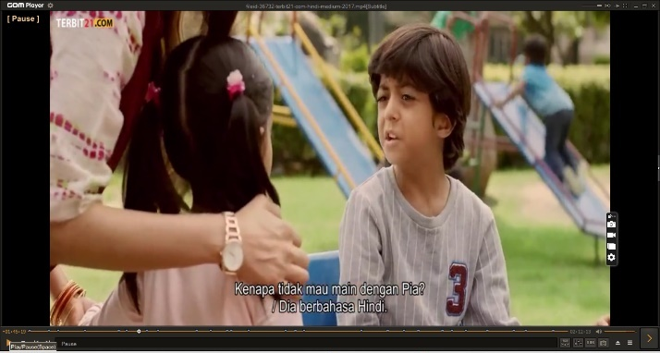

Meeta's fear that Pia will be ostracized for not being fluent in English is portrayed in a scene at the playground. When Meeta is sitting on the playground, Pia comes to her crying and says that Ayaan doesn't want to play with her. Meeta immediately asked Ayaan who was sitting on the turntable. Ayaan says he speaks Hindi. Mama said, don't speak Hindi”. Ayaan doesn't want to play with Pia because he uses Hindi. Pia can't speak English and can only speak Hindi so he doesn’t make friends because among the elite it is mandatory and she has to be able to speak the language English, his mother forced him to learn English. This made Meeta even more determined to send Pia to the best private schools.
From this scene, it can be interpreted that English has a big influence on everyday life. Those statements are related to education as a social class. Hindi Medium films emphasize the importance of the language British in India. Because English is not just learning, but also determines one's social class position. It can be seen from the storyline of the film and the origin of the film itself. Indians who get the best education using English.
The search for the best school for Pia does not go smoothly, several private schools reject Pia because of Raj and Meeta's educational background. As the consultant said “All these schools do not allow children of shopkeepers. “It is true that you are a businessman”. But the school assumes that the parents are not highly educated. So, parents don't pay attention to the height or not, the education of their children." The educational background of parents is very influential in children's education. Wealth does not easily make children accepted in private schools.

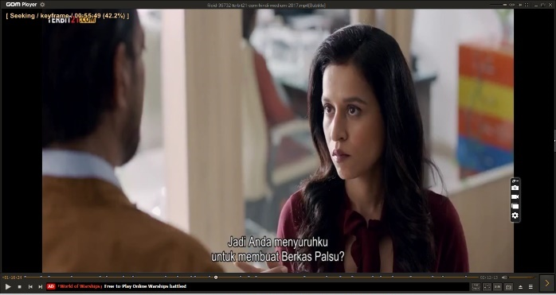

Meeta wants her child to go to Delhi Grammar School. This Delhi Grammar School has a requirement that those who are accepted at the school are students who live within a 3 km radius. So Meeta and her husband moved to Vasant Vihar to get their daughter accepted into the school. Then after they applied to the Delhi Grammar School, they found out that the parents had to do the interview too and they weren't ready for that, so they went to the consultant who taught them. Raj had not fully prepared the answers to answer the questions in the interview session, so their daughter was not accepted at any private school.

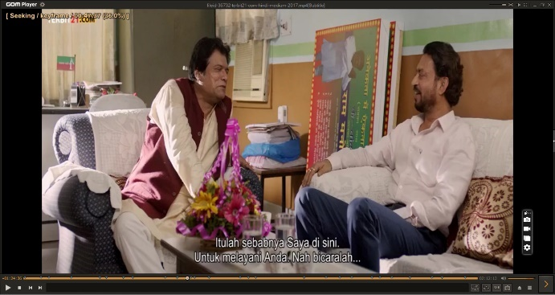 | 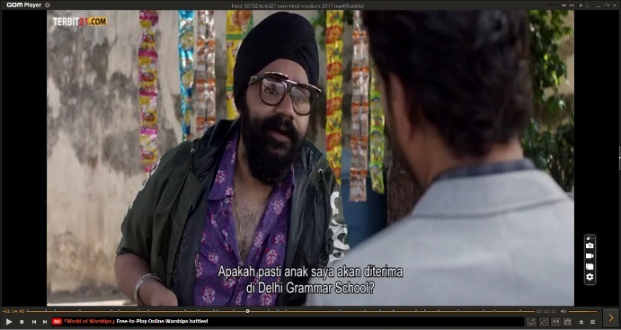

Raj tries various ways to get his daughter accepted at the school. Raj also meets with influential politicians and tries to bribe the principal by giving donations and so on, but nothing works. Raj asks someone for help touts who are also tea sellers for taking care of the files so that Pia can be accepted via the RTE route. A tea seller has experience in taking care of it. The tea seller admitted that the customers came from government officials to businessmen.

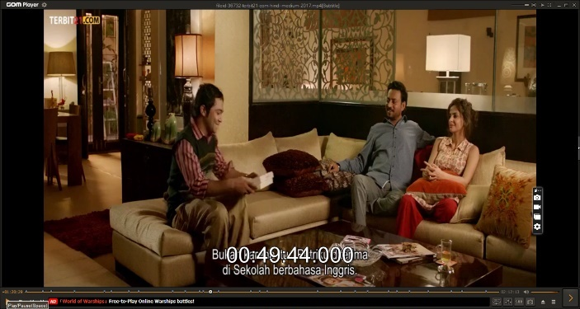

The problem comes when the quota of students at the school is limited. For one reason or another, Raj and Meeta justify any means so that their child is accepted. His efforts started with moving houses according to the school's zoning, intending to bribe the school principal, to the peak of pretending to be poor and falsifying a certificate of incapacity or "right education".

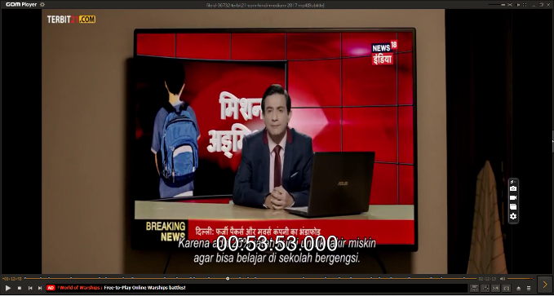 | 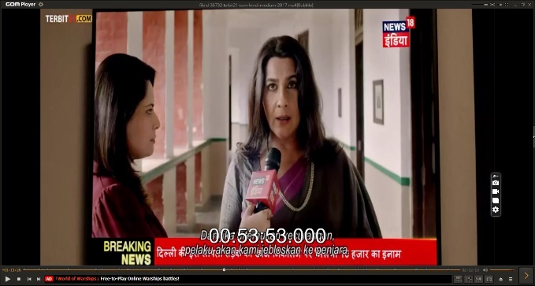

Meeta always blames Raj for various situations, even though Raj does everything he can to get Pia accepted at a private school and make Meeta happy. For example, during the scene in the room, Raj is watching television and finds out that the applicants for the RTE line will be surveyed by the Delhi Grammar School. If caught cheating, it will be reported to the police. In the dialogue that was delivered, Meeta always cornered Raj "Oh my gosh, because of you we are in big trouble. What about me and Pia, when you end up in jail? What should I answer if he asks where his papa is? Meeta doesn't realize that everything Raj does is because of his orders.

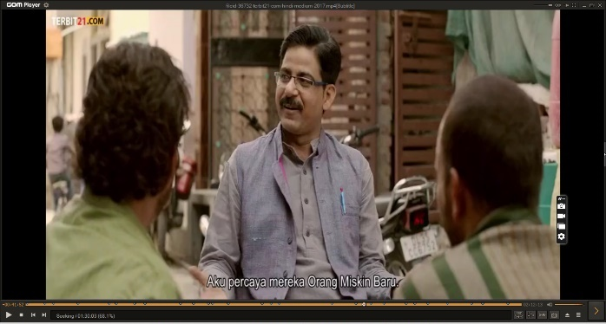 | 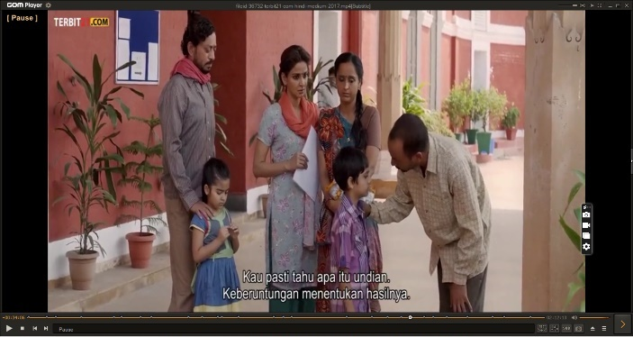

Raj and Meeta asked the employee and the employee explained that her daughter had received a quota from the Right to Education (RTE) which was specifically allocated by the government for students who were among the poor. Then Raj and his wife took their daughter to Delhi Grammar School by utilizing the Right to Education (RTE) quota to get forms for her daughter to enter. Raj and his wife registered their son with that line by falsifying documents. It wasn't long before the school learned that there were parties who falsified documents to get accepted at the Delhi Grammar School. The Delhi Grammar School then sent one of its representatives to conduct a field survey of parents who submitted applications with an indigent track. Then Meeta invites Raj to pretend to be a poor man. They came to the slum rented a house and changed their appearance.

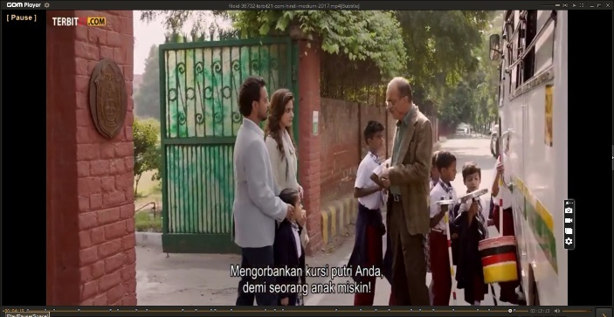 | 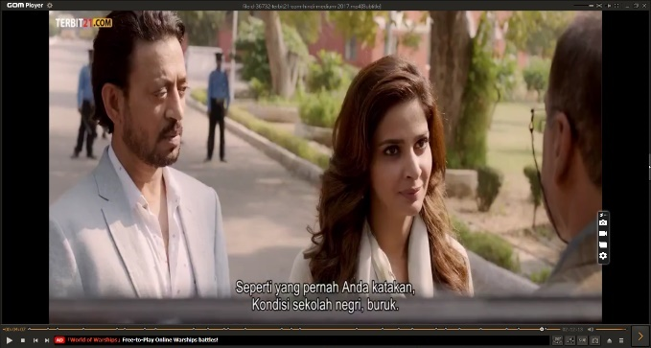

Finally, Raj admits all his guilt for cheating and taking Shyam's child rights. “A lot of parents want. Like us, who think 'If my child goes to school here, then he will be a great person' until he has to do this, for him. We live in slums in Bharat Nagar, stealing from others, lying, cheating, and so on.” Not all parents agreed with Raj's opinion, as seen from the attitude of the parents who remained seated in the auditorium and did not appreciate Raj's honest attitude. Meanwhile, Meeta finally realizes that private schools are not always great. The success of a child depends on the ability and will he has. Formal education is a means to open children's mindsets and insights.

Importance of Representation of Education in Film
A film is constructing a representation of events (Zacks, 2013). According to Wildgen & Heusden (2009), a film can represent some issues that have long been subject to discussion in it. The story “Hindi Medium” actually comes from a simple problem. The conflict is only limited to telling middle-class families who want to send their children to the best schools in Delhi. Just like the wishes of people in general, always want to give whatever is best for their favorite child. However, it turns out that choosing the best school is not an easy thing, they have to find various ways to achieve this goal.
As the story progresses, the conflict begins when Raj, who incidentally is a rich businessman, uses the Right to Education (RTE) route to enter Delhi Grammar School. The school, which received information about the irregularities in the RTE line, did not remain silent. They did visitation to all the families who volunteered. Raj and his family also have to pretend to be poor people by renting a house in a slum area. According to Bhattacharya and Jiang (2021), Scholars have expressed doubts about India's 2009 Right to Education (RTE) Act, which mandates universal education, despite its ambitious scope. The educational medium has not been fully addressed in these discussions. The RTE Act recognizes "disadvantaged" children as linguistic minorities and mandates that the "medium of instruction shall, to the extent practical, be in the child's mother language," but provides little other guidance. More than 1,652 languages are spoken in India, yet only 43 are used as instructional mediums. Consequently, the majority of children learn in a language that is not their native tongue, suffering severe scholastic disadvantages. It remains to be determined how this issue hinders the RTE Act's objective.
Apart from entertaining the audience through the failures that the Batra family often experiences. The film "Hindi Medium" is also a medium for criticizing the education system that may be happening around us. Watching Meeta's ambition of wanting to send her children to a good place, finally shows an education system full of dirty practices. Such as fraud in the school registration process, fraudulent forgery of documents, the practice of bribing school principals, assessing the ability of children from their parents' backgrounds, and other complicated problems. Meeta is a reflection of all of us, parents who have high ambitions to place our children in the best schools for their children's development. What a play can be done well. Moreover, feelings of defeat and envy immediately arise when employees who can't afford it get into an elite school in New Delhi, Prakriti School. The way for the rich to get into the best private schools by pretending to be poor is the human instinct to try all means.
This film “Hindi Medium” frames criticism of the education system through a satirical comedy-drama that is built from the conflicting roles of the characters, and the dialogues that are always right. Apart from that, this film will make us realize that sometimes school is only a tool for parents to maintain their prestige. Apart from the issue of a chaotic education system, the film can also naturally convey a message about the gap between the rich and the poor. This a portrait of the Batra family, which is a well-to-do family but still feels deprived of everything that cannot be reached. The story of Sham Prakash's family who is poor but full of gratitude will make us learn to contemplate the problems they face. This film shows how India's social dynamics place English as the prestige of people who are respected and deserve respect. So even if we are rich, if we cannot speak English, it will be difficult for us to be accepted in the upper class. For many parents in India, a good education is getting an English education (Rusmayanti, 2019).
The Hindi Medium film shows that Education greatly influences a person's social class. in times modern education determines social class, no longer by wealth which is inherited from generation to generation. Apart from that, Hindi Medium films also persuade the audience to leave the patriarchal culture that is usually displayed through the media and is still attached to culture in India. Women have the same ability and right to compete with men. In the film Hindi Medium, social inequality is visible between the elite and the poor in India, both in terms of access to basic needs and education. Here, it is visualized how rich parents easily obtain proper education for their children. Meanwhile, the poor have to wait for a small slot to enter the best schools in India, through a special route that draws 20 poor children. Drawn every year. Today's academics have grown so competitive that youngsters are often willing to sacrifice their lives to escape the strain. With their emphasis on their children being physicians and engineers, Indian parents add to the problem (Kottary & Sarda, 2021).
Films are a complicated entity that simultaneously represents an art form, an influential industry, and a social phenomenon (Jukić et al., 2010). The movie is a representation of society (Monti & Rozzonelli, 2015). Masruro et al. (2021) add that films sometimes record the reality that grows and develops in society and is then projected onto the screen. This film shows the representation of education in society. According to LaDousa & Davis (2021), the Bollywood film Hindi Medium was praised for its insightful investigation of class-based aspirations in India revolving around the subject of a medium of instruction. This film also shows how India's social dynamics place English as the prestige of people who are respected and deserve respect. So even if we are rich, if we cannot speak English, it will be difficult for us to be accepted by the upper class. This film is about a rich family, but not among intellectuals, for example, not a lecturer's child, an educated person's child, or a rich smart person, Pia is just the daughter of a wedding dress businessman who does not even speak English. In the end, Hindi Medium shows that sometimes school is a tool for parents to maintain prestige. They can even cheat to get the best seats. While children study harder and force themselves in the name of getting the best education so that their parents' ego is maintained.
In "Hindi Medium," representation plays a pivotal role in dissecting various societal intricacies. Firstly, the film meticulously delineates the socioeconomic chasm, starkly portraying the divide between the affluent and the less privileged, particularly evident in access to education. Secondly, it navigates the intricate terrain of language barriers, emphasizing the significance of English-medium education and the challenges faced by those lacking proficiency in the language. Thirdly, "Hindi Medium" delves into the depths of parental aspirations, vividly depicting the lengths to which parents go to secure their child's educational future, often confronting the complexities of the system and resorting to unconventional means. Fourthly, the film employs satire and humor as its primary tools, effectively critiquing the flaws within the education system and broader societal structures. Fifthly, it touches upon the delicate balance between cultural identity and assimilation, highlighting the tension arising from the prioritization of English-medium education over cultural preservation. Lastly, "Hindi Medium" illuminates the privilege and entitlement entrenched within elite private schools, shedding light on preferential treatment and the disregard for students from less privileged backgrounds. Together, these representations form a comprehensive narrative that prompts reflection on the multifaceted issues surrounding education, social class, and cultural identity in contemporary Indian society.
The first impression that the researcher felt after watching this Hindi Medium film was that the researcher felt that there was a resemblance to doing a selection and choosing a school for my children. Then some people act as an educational mafia. The educational mafia is an element that assists parents in cheating data so that their children can be accepted at the school they want. They do not even care because of the fraudulent act; they can take other people's rights. The researcher is increasingly convinced that every parent must strive for the best education for their child. But we do not do anything to cheat and harm others. This film carries a social message regarding the education system where parents compete so that their children can enter elite schools because they think that these schools can provide the best education for their children.
The representation of education in film is paramount for several reasons. Firstly, the representation of education in film serves as a mirror reflecting the realities of educational institutions, classrooms, and the lives of students and teachers. By capturing the nuances and complexities of educational experiences, these cinematic portrayals provide audiences with a deeper understanding of the challenges, triumphs, and dynamics present within these environments. From the struggles of individual students to the dedication of educators, these films offer a comprehensive look at the multifaceted nature of education. Secondly, films about education hold significant sway over public perceptions and attitudes towards learning. Through compelling storytelling and vivid imagery, these movies shape how society views the value and importance of education. Positive representations of education can inspire viewers to appreciate the transformative power of learning, fostering a culture that values knowledge acquisition, critical thinking, and personal growth. Thirdly, movies about education often serve as a platform for social commentary, shedding light on pressing issues such as educational inequality and the impact of socioeconomic disparities on academic outcomes. By tackling these themes head-on, these films prompt audiences to reflect on the systemic barriers that hinder equal access to quality education and inspire conversations about potential solutions and reforms. Fourthly, the narratives of resilience, determination, and community support depicted in these films have the power to inspire and empower viewers. Stories of students overcoming adversity, teachers going above and beyond to make a difference, and communities rallying together to support education can instill a sense of hope and motivation in audiences, encouraging them to overcome their challenges and strive for success. Lastly, the representation of diverse perspectives and experiences within the educational landscape contributes to cultural understanding and inclusivity. By showcasing the richness and diversity of educational experiences across different communities and cultures, these films foster empathy, appreciation, and respect for the varied ways in which people engage with and navigate the world of education.
In summary, the depiction of education in film is not merely entertainment; it serves as a powerful tool for education, enlightenment, and social change. By capturing the essence of educational experiences and addressing important societal issues, these cinematic portrayals stimulate dialogue, promote empathy, and inspire action toward creating a more equitable and inclusive educational system.

Conclusion
The film Hindi Medium is about the search for schools by married couples who want good quality or favorite schools and also prioritize English as the best view for their children. Because it was feared that his son would fail in the future if he did not enter to favorite schools, qualify, and speak English according to their paradigm. The concept of education as above in general also exists in Indonesia and happens to parents who want their children to go to schools. But that is not the only way because many other factors affect the child's future, which can be internal and external sources. This film carries a social message regarding the education system where parents compete so that their children can enter elite schools because they think that these schools can provide the best education for their children. Apart from entertaining the audience through the failures that the Batra family often experiences. This film is also a medium for criticizing the education system that may be happening around us where parents are competing to send their children to elite schools because they think these schools can provide a better quality of education for their children.
This film carries a social message regarding the education system where parents compete so that their children can enter elite schools because they think that these schools can provide the best education for their children. Apart from entertaining the audience through the failures that the Batra family often experiences, this film is also a medium for criticizing the education system that may be happening around us. Watching Meeta's ambition of wanting to send her children to a good place, finally shows an education system full of dirty practices, such as fraud in the school registration process, fraudulent forgery of documents, the practice of bribing school principals, assessing the ability of children from their parents' backgrounds, and other complicated problems. This film can frame criticism of the education system through a satirical comedy-drama that is built from the dialogue and conflicting roles of the characters. Apart from that, this film will make us realize that sometimes school is only a tool for parents to maintain their prestige.
The research is based solely on the analysis of the film "Hindi Medium" and its portrayal of the education system, without considering real-life data or empirical evidence. The scope of the research is limited to the themes presented in the film and does not encompass a broader analysis of the education system or parental aspirations in society. The research does not explore the perspectives of educators, policymakers, or students, which could provide valuable insights into the complexities of the education system. It may overlook nuances and variations in the education system across different regions and socio-economic backgrounds, as depicted in the film.
Future research could involve empirical studies to explore the extent to which parents prioritize elite schools and English-medium education for their children, and the factors driving these preferences. There is a need for longitudinal studies to examine the long-term outcomes of students who attend elite schools compared to those who do not, understand the actual impact of school choice on academic achievement and future success. Research could delve into alternative models of education and parental involvement that prioritize holistic development and individual talents, rather than solely focusing on academic prestige. There is an opportunity to investigate the role of socioeconomic status, cultural factors, and government policies in shaping parental attitudes toward education and school choice. Comparative studies across different countries, including Indonesia, could provide insights into the similarities and differences in parental aspirations and the education system's dynamics.

References
Andhita, P. R. (2021). Komunikasi Visual. Zahira Media Publisher.
Bhattacharya, U., & Jiang, L. (2021). : Medium and dis-citizenship. In Language, Education, and Identity. Routledge India.
Chairul, B. A. (2022). Representasi Pendidikan Suku Boti Dalam Film “Boti” (Studi Semiotik representasi pendidikan suku boti dalam film “boti” karya watch doc) [Undergraduate Paper, Universitas Pembangunan Nasional Veteran]. http://repository.upnjatim.ac.id/7538/
Deb, S., Majumdar, B., & Sunny, A. M. (2021). Youth Development in India: Future Generations in a Changing World. Taylor & Francis.
Ersyad, F. A. (2022). Semiotika komunikasi dalam perspektif Charles Sanders Pierce. CV. Mitra Cendekia Media.
Fitria, T. N. (2021a). Characterization Analysis of the Main Character in Hichki Movie. Vivid: Journal of Language and Literature, 10(1), 6–17. https://doi.org/10.25077/vj.10.1.6-17.2021
Fitria, T. N. (2021b). Representation of Symbols in “Parasite” Movie. ISLLAC : Journal of Intensive Studies on Language, Literature, Art, and Culture, 5(2), 239–250. https://doi.org/10.17977/um006v5i22021p239-250
Fitria, T. N. (2022). Analysis of Human Struggle of Main Characters in Indian Drama Film “Black” (2005). LET: Linguistics, Literature and English Teaching Journal, 12(1), 107–130. https://doi.org/10.18592/let.v12i1.6373
Flick, U. (2013). The SAGE Handbook of Qualitative Data Analysis. SAGE Publication.
Ghadially, R. (2007). Urban Women in Contemporary India: A Reader. SAGE Publication.
Hair, A. (2017). Analisis Tema Film India Terbaik Di Stasiun Televisi Indonesia Periode 2011-2015 [Undergraduate Paper, Institut Seni Indonesia Yogyakarta]. http://lib.isi.ac.id
Hall, S. (2020). The work of representation. In The Applied Theatre Reader (pp. 74–76). Routledge. https://doi.org/10.4324/9780429355363-15
Handayani, M. A. (2006). Studi Peran Film dalam Dunia Pendidikan. INSANIA : Jurnal Pemikiran Alternatif Kependidikan, 11(2), 176–186. https://doi.org/10.24090/insania.v11i2.166
Heryanti, D., & Harini, Y. N. A. (2018). Representasi Pendidikan Pada Film Jembatan Pensil. Fon: Jurnal Pendidikan Bahasa Dan Sastra Indonesia, 13(2). https://doi.org/10.25134/fjpbsi.v13i2.1541
Imam, M., & Nurdyansa. (2022). Representasi Perempuan dalam Iklan. Insan Cendekia Mandiri.
Jukić, V., Brečić, P., & Savić, A. (2010). Movies in Education of Psychiatry Residents. Psychiatria Danubina, 22(2), 304–307. https://hrcak.srce.hr/55835
Kottary, G., & Sarda, R. (2021). Healing at the Movies: How Indian Films Can Educate and Sensitise Us. Hay House, Inc.
LaDousa, C., & Davis, C. P. (2021). Language, Education, and Identity: Medium in South Asia. Taylor & Francis.
Masruro, I., Prasetyoningsih, L. S. A., & Ambarwati, A. (2021). Menggagas Pembelajaran Sastra Indonesia Pada Era Kelimpahan. UNISMA PRESS.
Monti, A., & Rozzonelli, C. (2015). Experiments in Film Appreciation. Lulu.com.
Nikmah, A. F. (2022). Representasi Budaya Pendidikan Di Indonesia Pada Film Jembatan Pensil (Analisis Semiotika Dalam Film Jembatan Pensil) [Undergraduate Paper, Universitas Muhammadiyah Surakarta]. http://eprints.ums.ac.id/103308/
Prasetya, L. T. (2022). Representasi Kelas Sosial Dalam Film Gundala (Analisis Semiotika Roland Barthes). Jurnal Audiens, 3(3), Article 3. https://doi.org/10.18196/jas.v3i3.12697
Putri, N. F. (2022). Representasi Pendidikan Anak Jalanan Dalam Film Stip & Pensil [Undergraduate Paper, Universitas Muhammadiyah Surakarta]. http://eprints.ums.ac.id/105733/
Rachman, R. F. (2020). Representasi dalam Film. JURNAL PARADIGMA MADANI, 7(2), 10–18. http://ejurnal.uij.ac.id/index.php/PAR/article/view/832
Rusmayanti, R. (2019). Representasi Pendidikan Sebagai Kelas Sosial Dalam Film Hindi Medium [Undergraduate Paper, Universitas Bakrie]. https://repository.bakrie.ac.id/3021/
Setiaputri, D. A. (2015). Representasi pendidikan di perbatasan dalam film “Batas” [Undergraduate Thesis, Widya Mandala Catholic University Surabaya]. http://repository.ukwms.ac.id/id/eprint/6633/
Sondhi, N., Panigrahi, R., Pang, M., & Chatterjee, R. (2020). Comparative Development of India & China: Economic, Technological, Sectoral & Socio-cultural Insights. SAGE Publishing India.
Susanto, D. (2021). Bahasa Dan Sastra Dalam Kajian Kontemporer. Penerbit Lakeisha.
Viswamohan, A. I., & Wilkinson, C. M. (2020). Stardom in Contemporary Hindi Cinema: Celebrity and Fame in Globalized Times. Springer Nature.
Wibowo, G. (2019). Representasi Perempuan dalam Film Siti. Nyimak: Journal of Communication, 3(1), 47–59. https://doi.org/10.31000/nyimak.v3i1.1219
Wicaksono, A. (2021). Antara Fiksi dan Realita: Representasi Revolusi Nasional 1945-1949 dalam Novel Indonesia. Garudhawaca.
Wildgen, W., & Heusden, B. van. (2009). Metarepresentation, Self-organization and Art. Peter Lang.
Zacks, J. M. (2013). Constructing event representations during film comprehension. In Psychocinematics: Exploring cognition at the movies (pp. 227–243). Oxford University Press. https://doi.org/10.1093/acprof:oso/9780199862139.003.0012
Zoebazary, M. I. (2013). Kamus Istilah Televisi & Film. Gramedia Pustaka Utama.

